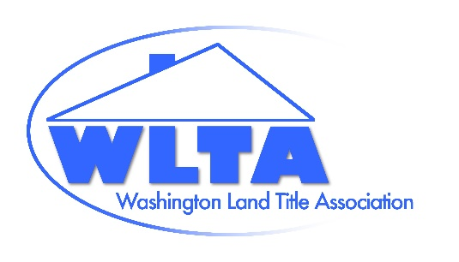
Washington Land Title Association
https://washingtonlandtitle.com
Mail: PO Box 328, Lynnwood, WA 98046
Delivery: 6817 208th St SW, #328, Lynnwood, WA 98036
206-260-4731 (Fax)
George Peters, Co-Executive Director, 206-437-5869
Sean Holland, Co-Executive Director, (206) 697-4199
execdirector@washingtonlandtitle.com
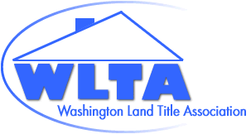
2025-2026 Officers
Ashley Callahan, President
Anthony Carollo, Vice President
Jim Blair, Immediate Past President
2024-2026 Directors
Ben Case
Lindsy Doucette
Gerry Guerin
Gale Hickok
Paul Hofmann
Peter Johndrow
Dan MacMillan
Maureen Pfaff
Jensen Salisbury
2025-2027 Directors
Lori Bullard
Bernt Nesset
Chris Rollins
Erin Stines
Craig Trummel
Committee Chairs
*Marcella Carey-Agent Section
*Megan Powell-Underwriter Section
*Sari-Kim Conrad-OIC Liaison
*Michelle Taylor, *JP Kissling & Maureen Pfaff-Legislative
Allison Davis-Judiciary
Megan Powell-Native American Affairs
Gerry Guerin & Rick Randall-Education
Lori Bullard & Allison Davis-Examiners Manual
Paul Hammann-Membership
Paul Hofmann-WTP, TITAC, TAN, Technology
Jim Blair-Nominating
Craig Trummel, Grievance
(*Automatic Board Member)
January 9, 2026

Washington State Office of the Insurance Commissioner
VIA Email to: rulescoordinator@oic.wa.gov

Dear Commissioner’s office:

The Washington Land Title Association (WLTA) writes to comment on the January 8. 2026 Third Prepublication Draft of R2025-05 entitled Clarifying and Updating the Minimum Standards for Claims Handling. WLTA’s members include many title insurers (underwriters) and title agents licensed to do business in the State of Washington.

The proposed changes to Washington Administrative Code (WAC) 284-30-340 – File and record documentation continues to concern the WLTA.

The existing rule states that an insurer’s claim file is subject to examination by the commissioner or a duly appointed designee. The file must contain “all notes and work papers pertaining to the claim in enough detail that pertinent events and dates of the events can be reconstructed.” For a title insurer, this typically includes the notice of claim and any supporting documentation, the insurer’s acknowledgment of it, notes regarding any communications with the insured about the claim, and the insurer’s coverage determination letter.

The proposed rule would require the title insurer to produce to the insured “[a]ny portion of the first party claim file, including but not limited to, all written reports, claim notes, estimates, bids, plans, measurements, drawings, engineer reports, contractor reports, statements, photographs, video recordings or any other documents or communications” unless the record is legally privileged, contains third party financial information, or is essential to reasonable investigation of alleged criminal activity. For a title insurer, this could mean disclosure of proprietary business information and – again – information from third parties that an insured may not be legally entitled to.

A title claim investigation, and therefore the “claim file,” often involves a review of title and escrow files. A title file generally contains information about the title insurer’s underwriting process, e.g., policy write ups, property runs, and internal business communications. This is proprietary business information owned by the title insurer. Disclosure, if any, should be (and has been) limited to a subpoena or court order so that legal experts may evaluate the relevance and weigh the consequences of production. While an insured is entitled to understand how or why a title claim is covered under the title policy that was issued to that insured, an insured is not entitled - absent a subpoena or court order - to obtain an insurer’s internal and proprietary considerations about how it underwrites a particular title risk, issues a form of policy, or otherwise does business.

Regarding the escrow file, the WLTA appreciates that an exception has been carved out for third-party financial information. However, the proposed rule falls short and, as proposed, stands a very good chance of increasing litigation for insureds and insurers alike. A common title claim is when a neighbor asserts an interest in the insured’s land. The claim file may contain notes between the title claim adjuster and the neighbor, or documents, photographs and recordings provided by the neighbor to the title claim adjuster on a confidential basis. The proposed rule forces the title insurer to either produce such records to the insured or limit its own claim investigation because of the threat of production. None of these concerns, including the unintended consequence of increased litigation, exist if the process by which an insured obtains third-party information from a title insurer’s claim file is by way of a subpoena.

The WLTA’s prior letters regarding the proposed rulemaking dated August 8, 2025 and October 3, 2025 are incorporated and referenced herein. To reiterate, the WLTA proposes to retain the existing Washington Administrative Code (WAC) 284-30-340 or exempt title insurers from the proposed changes to it.

Thank you for the opportunity to provide input. We appreciate your consideration of this important matter.
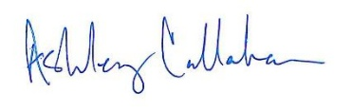

Ashley Callahan
President
Washington Land Title Association

cc: WLTA Board

