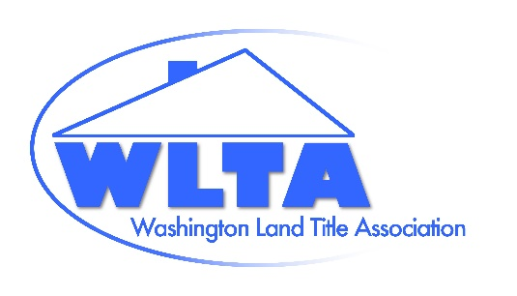
Washington Land Title Association
https://washingtonlandtitle.com
Mail: PO Box 328, Lynnwood, WA 98046
Delivery: 6817 208th St SW, #328, Lynnwood, WA 98036
206-260-4731 (Fax)
George Peters, Co-Executive Director, 206-437-5869
Sean Holland, Co-Executive Director, (206) 697-4199
execdirector@washingtonlandtitle.com
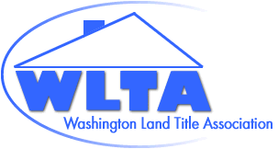
2025-2026 Officers
Ashley Callahan, President
Anthony Carollo, Vice President
Jim Blair, Immediate Past President
2024-2026 Directors
Ben Case
Lindsy Doucette
Gerry Guerin
Gale Hickok
Paul Hofmann
Peter Johndrow
Dan MacMillan
Maureen Pfaff
Jensen Salisbury
2025-2027 Directors
Lori Bullard
Bernt Nesset
Chris Rollins
Erin Stines
Craig Trummel
Committee Chairs
*Marcella Carey-Agent Section
*Megan Powell-Underwriter Section
*Sari-Kim Conrad-OIC Liaison
*Michelle Taylor, *JP Kissling & Maureen Pfaff-Legislative
Allison Davis-Judiciary
Megan Powell-Native American Affairs
Gerry Guerin & Rick Randall-Education
Lori Bullard & Allison Davis-Examiners Manual
Paul Hammann-Membership
Paul Hofmann-WTP, TITAC, TAN, Technology
Jim Blair-Nominating
Craig Trummel, Grievance
(*Automatic Board Member)
October 3, 2025

Washington State Office of the Insurance Commissioner
VIA Email to: rulescoordinator@oic.wa.gov

Dear Commissioner’s office:

The Washington Land Title Association (WLTA) writes to comment on the September 25, 2025 Second Prepublication Draft of R2025-05 entitled Clarifying and Updating the Minimum Standards for Claims Handling. WLTA’s members include many title insurers (underwriters) and title agents licensed to do business in the State of Washington.

The proposed changes to Washington Administrative Code (WAC) 284-30-340 – File and record documentation continues to be concerning to the WLTA. The proposed language continues to require an insurer to produce all claim file documents and communications to an insured within 15 business days of an insured’s request. The proposed rule allows the insurer to withhold “legally privileged” material, “third-party financial information”, and documents specifically related to investigation of criminal activity, but this exception is still insufficient to protect third parties from potential harm.

Again, a title insurer’s claim file may include non-public information documents related not only to a seller’s finances, but also other third-party communications involving, for example, realtors, brokers, or neighbors, that are related to the insured transaction. Such information is typically produced by the title insurer pursuant to a valid subpoena - a legal process which may require judicial review and notice to a third party. Even as written in the second prepublication draft, WAC 284-30-340 allows an insured to usurp the legal process established to protect the information of third parties. The additional language requiring a privilege log does nothing to mitigate this risk and instead may result in unintended consequences such as increased litigation and administrative burden.

The WLTA requests that the Commissioner’s office hold additional stakeholder meetings to discuss the proposed changes to WAC 284-30-300 through 284-30-400 and to further evaluate and consider the implications thereof.

Thank you for the opportunity to provide input.
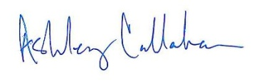

Ashley Callahan
President
Washington Land Title Association

cc: WLTA Board

