Rohit Chopra
Consumer Financial Protection Bureau
1700 G Street NW
Washington D.C. 20552

Re: Docket Number CFPB-2024-0021-0001: Request for Information Regarding Fees Imposed in Residential Mortgage Transactions

Director Chopra,
Housing opportunity and affordability is a daunting issue facing Americans. Government and industry must work hand in hand to increase the supply of housing at all price points, ensuring the dream of homeownership remains an achievable reality. That mean ensuring that when American’s buy their home, they actually own it and are not at risk of losing that investment. Title insurance does this. It is also one of the least expensive services and products available to consumers in a real estate transaction. In fact, while the request for information notes that the price of homes and total closing costs have gone up in recent years, the cost of the average premium for title insurance is actually down roughly 5% in the past 5 years on a nominal basis and roughly 36% on a constant dollar basis.
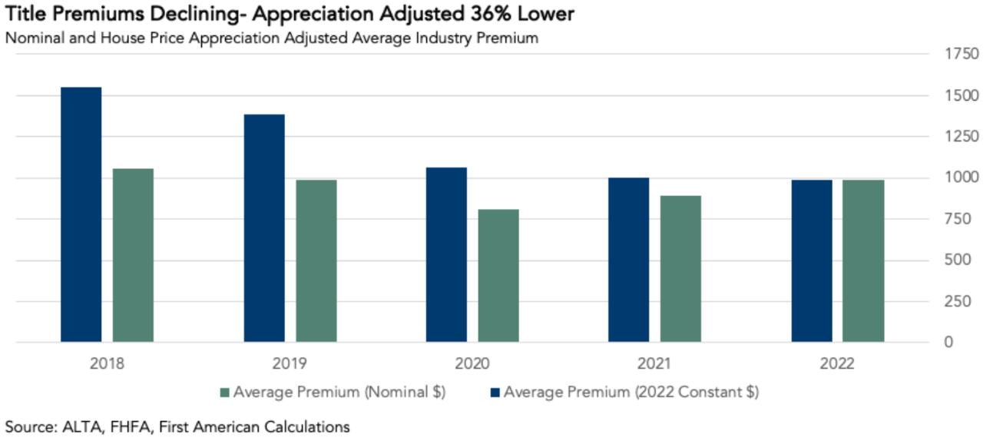
The American Land Title Association (ALTA) welcomes the chance to work with the Bureau to ensure that consumers have the best information for cost effectively protecting their property rights. As the Bureau notes, “increased pressure on borrowers’ budgets, contributing to a lack of access to credit and decreased home affordability” is a concern we all share. However, we are concerned the use of rhetoric like “junk fees” when discussing various costs will encourage consumers to forgo some necessary protections like title insurance. Given our concern, this letter provides background about title insurance, the marketplace for title services and an analytic framework for understanding the value and adequacy of the price. Lastly, this letter will provide answers to questions 1, 2, 4, 5 and 8 of the RFI.
Title insurance is one of the most transparent markets for consumers.
When buying a home, consumers need to know that they actually own the property. This is what makes title insurance so critical.
Title companies provide two major services to insure a consumer’s property rights. First, title companies conduct title research. This encompasses three main components: 1) a search of title related public records; 2) an examination of those records to determine their impact on the buyers’ rights and the validity; and 3) curative work to uncover other debts of the seller or defects in title that need to be addressed prior to the buyer taking ownership, much of which cannot be identified in the public records. The goal is to ensure the consumer takes title subject to only those rights of others that are reasonable (such as a utility easement). This concept is called marketable title.
Second, the title company will conduct the real estate closing or settlement. This involves the coordination of paying off all the debts discovered in the curative phase and the execution of the legal (and other documents) necessary to complete the sale and the mortgage financing. The goal of the closing process is to ensure the executed transaction documents comply with both federal mortgage law and state real estate law. This process can have a myriad closing options such as using a mobile or electronic notary or courier services to send documents where necessary for the convenience of the consumer.
Both these services are then backed by insurance. The industry offers three core insurance products in a transaction, a loan policy protecting the lender’s lien priority, an owners’ policy protecting the buyer’s property rights and a closing protection letter insuring the transfer of funds and proper execution and recording of transaction documents at closing. One of the critical values of the insurance products is to protect against defects that are not discernable in a public records search such as fraud and forgery.
Title insurance is a risk elimination product. Subsequently, the majority of the price consumers pay is to cover this upfront risk elimination expense. This is different from most other insurance products. In the average purchase transaction, the search, exam, curative and closing services take 22 hours of staff time to complete if no extraordinary defects or issues are found. However, in the 36% of transactions where there are extraordinary defects found, the time it takes to complete the transaction doubles to 45 hours. According the Treasury Department’s Financial Crimes Enforcement Network economic analysis, the fully loaded hourly wage for the title industry is $70.33 for title agents and $84.15 for title insurers.
The service heavy nature of the product also shows up in the cost of completing a transaction. For each dollar a consumer pays to a title company, 52 cents covers labor expenses, 17 cents covers purchasing title data from government entities and 13 cents covers office space. It is because of this high expense nature that state insurance regulators focus less on the loss ratio for title insurance for pricing adequacy and more on the combined ratio.
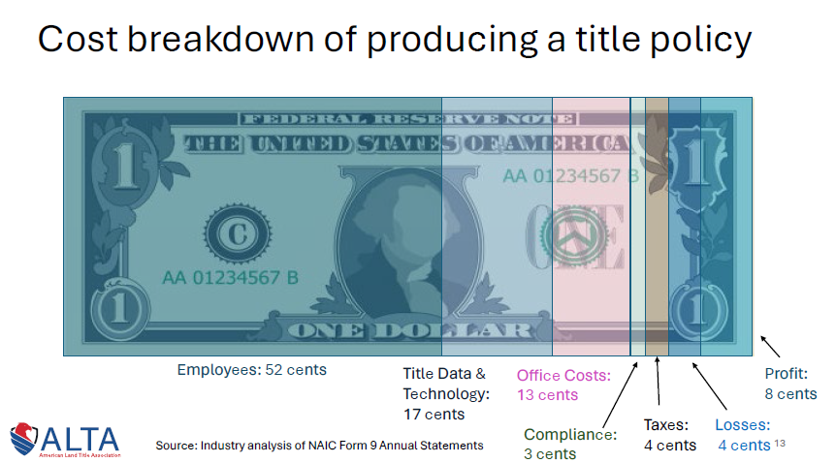
All of these services provided by the title company are paid for in a one time fee that is paid at closing. For the median homebuyer, the all-in costs of title insurance and settlement services is $1,901 or 0.67% of the purchase price according to Fannie Mae.
While consumers can always use more education about the mortgage and homebuying process, one area that consumers should be well informed is the price for closing costs and especially title insurance. Under the Bureau’s TILA-RESPA integrated disclosures (TRID) cost of title insurance and the connected services is disclosed to consumers at the start of the loan underwriting process and prior to closing. According to the Bureau’s own research about the TRID disclosures, “the evidence available for the assessment indicates that the TRID Rule improved consumers’ ability to locate key information, compare terms and costs between initial disclosures and final disclosures, and compare terms and costs across mortgage offers.”
Along with providing consumers with price disclosures, lenders also provide consumers with information to assist them in shopping for settlement services like title insurance. Further, because title insurance is a highly regulated product at the state level, insurer’s rates are available publicly through the department of insurance and many insurers have rate calculators on their websites. These calculators and related marketing help customers sift through different options found in their area.
Finally, it’s important for the Bureau to think about consumer shopping in the context of the entire real estate transaction. In a typical sale transaction, the buyer and the seller will often identify the title company in the purchase and sale contract (which will be prior to the lender accepting an application). This is done to assist the flow of the transaction, especially when the consumers are searching for a faster closing period. Often consumers obtain the advice of their real estate agent, the lender or a housing counselor to identify a title company. Like with mortgages in general, while price comparison shopping may not be common, the recommendations provided to consumers do factor in a host of traits including price, service, speed and ease of transaction due to technology or office locations.
The rest of this letter will provide specific responses to the questions posed by the Bureau in the RFI.
1. Are there particular fees that are concerning or cause hardships for consumers?
If there are fees that are causing hardship to consumers when buying a home, title insurance is not one of them. For most homebuyers title insurance and settlement are two of the least expensive components of the transaction.
As discussed above, the median homebuyer pays $1,901 or 0.67% of the purchase price for title insurance and settlement services according to Fannie Mae. This analysis likely over estimates the cost because it does not factor in how seller credits are used to reduce the cost of services to consumers. This is especially critical for understanding title insurance because in more then half the states, the seller pays for the owners title insurance policy for the benefit of the buyer.
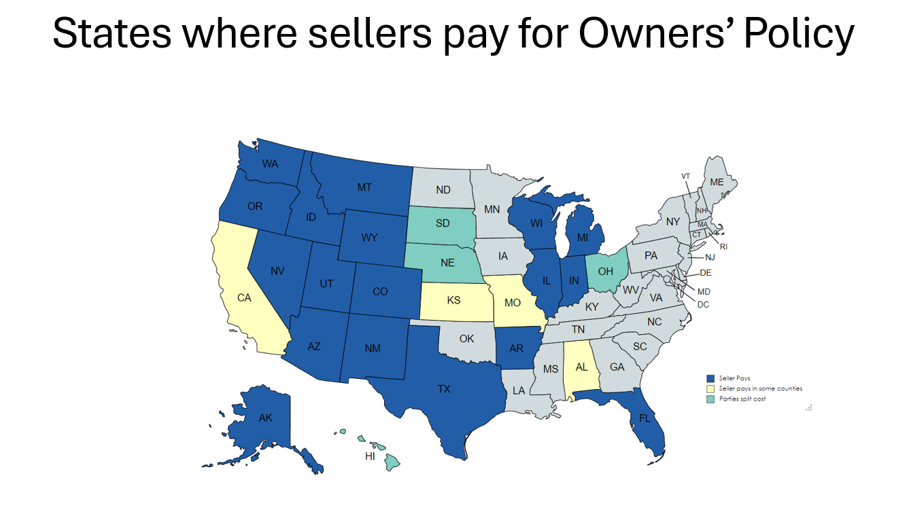
Additionally, the Fannie study also likely counted other third-party fees as part of the title charge even if they are not paid to the title company. According the Fannie study, they looked at data from the Uniform Closing Dataset for loans purchased. To determine title costs, they added together all fees that used the descriptor “Title –” since under TRID all title related fees are supposed to use that prefix. However, most lenders use that “Title –” prefix for any settlement related fee even if not paid to the title company such as fees for surveys, document couriers, notary services (both remote and in person), HOA estoppel or transfer fees and more. This practice further inflates the apparent cost of title insurance and settlement services to the consumer and policymakers.
While it’s important to look at costs in raw dollars and in relation to purchase price/loan amount, another critical way to examine closing costs is on a life of loan basis. This places closings costs in an apples to apples comparison against other costs that consumers pay on a recurring and annual basis as part of owning and financing a home. The result is a deeper understanding of what drives housing sustainability.
When using this lens, the low cost of title insurance and settlement services is even more apparent. On a life of loan basis the borrower’s largest life-of-loan costs are the property taxes , recording fees paid at closing and fees paid to the mortgage-backed security (MBS) investor. By comparison title insurance premium and settlement costs are two of the lowest costs on this basis, barely equating to 0.7 percent of the borrower’s total life-of-loan costs.
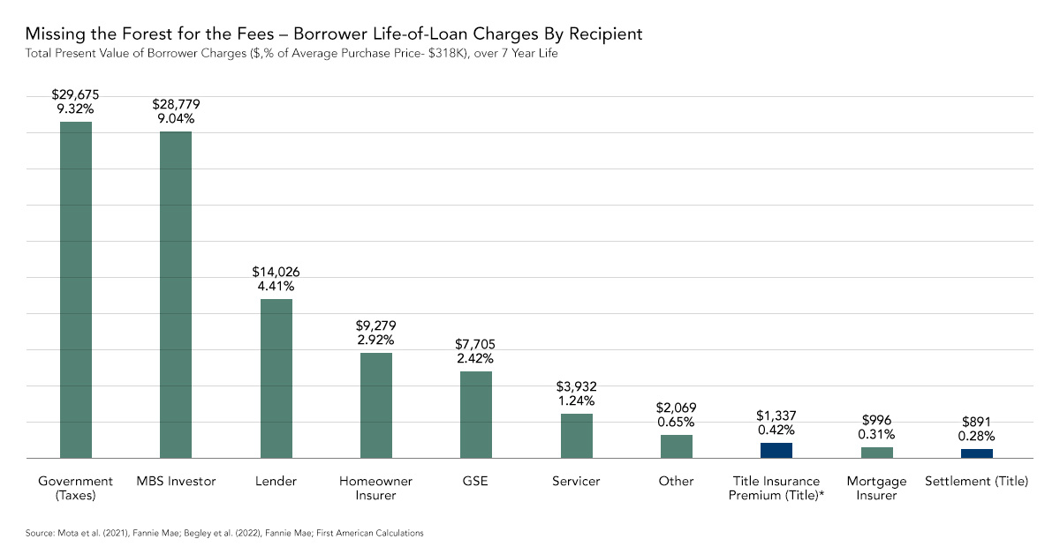
2. Are there any fees charged that are not or should not be necessary to close the loan?
It is clear that if there is a service that is absolutely necessary to close a loan it’s the service of determining the marketability of title and the safe and efficient settlement of the loan aka title insurance. Property rights risk can be complex because “ownership” of real estate is a “bundle of rights” that can be divided in numerous ways and over time. This “bundle” can vary significantly from state to state and even by locality owing to the tremendous complexity of the laws governing American property rights.
Prior owners of property may have created interests in it by contract. This includes items like granting a mortgage or selling a mineral interest. Some may have consented to or suffered liens to be attached to the real estate. This includes involuntary liens like those for child support or mechanics liens. All of these interests and liens will affect the rights acquired by a new purchaser or lender.
While some of these rights or claims affecting real property might be theoretically found through a sufficiently diligent search of public records—assuming the records documenting these rights are properly indexed and therefore findable—many other “off-record” title defects can impose ownership risks on homeowners. Example include forged deeds, incorrect legal descriptions or lack of consent from undisclosed heirs. Because Americans’ homes are often their most valuable assets, these risks can significantly impact American’s wealth.
As discussed above, the labor-intensive process to determine title insurability both reduces ownership risk for buyers before closing but also provides insurance to cover those items even the most diligent title search could not find such as fraud, forgery, tax issues and HOA payments. According to a recent study conducted by First American Financial, on an annual basis the curative work performed by title companies addresses roughly $600 billion in property rights related risk for consumers prior to closing.
First American examined title commitments where its staff provided the search and examination. Those commitments showed items that would need to be addressed prior to closing and then estimated the risk of those items by comparing against the average cost of addressing similar claims. Using First American’s data going back for the past decade, the title industry risk exposure ranged from $600 to $900 billion a year. During the surge in sales and mortgage refinancing in the Pandemic total industry risk exposure surpassed $1 trillion a year. In 2023, the most recent year of available ALTA industry data, total industry risk exposure is estimated to have been almost $500 billion.
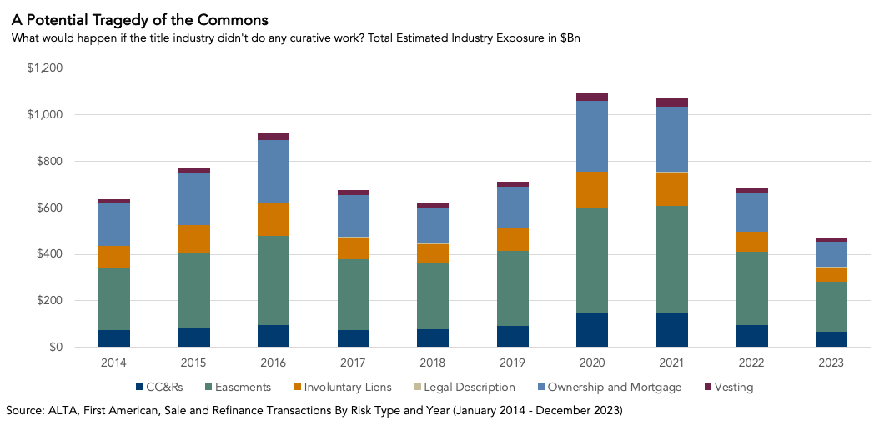
Moreover, when you compare the cost of eliminating or curing title risks against total title premium charged by the industry you see the relative cost of curation and insurance varies between two and three cents per dollar of premium collected per dollar of risk exposure.
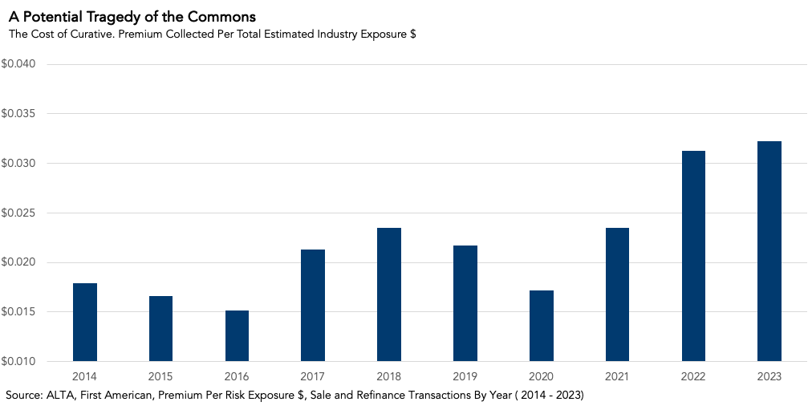

Another way to estimate the value of the curative work performed by title companies is to look at the number of documents recorded each year that require curation Based on an analysis of First American’s public records database, over the first nine months of 2023, roughly 5 million documents were recorded that require curation. This is in addition to the collection of information about items that need to be paid at closing like obtaining a mortgage release. This analysis found almost 1.9 million court judgments or orders; a million financing statements; nearly 900,000 local, city, utility, and other government related liens; 600,000 state and federal liens for unpaid taxes; over 200,000 HOA foreclosures; and 150,000 mechanics’ liens were found in the search of the public records. All these liens and judgments require an examination to determine if they impede the transfer or encumbrance of real property and if any curation or correction is required in the public records.
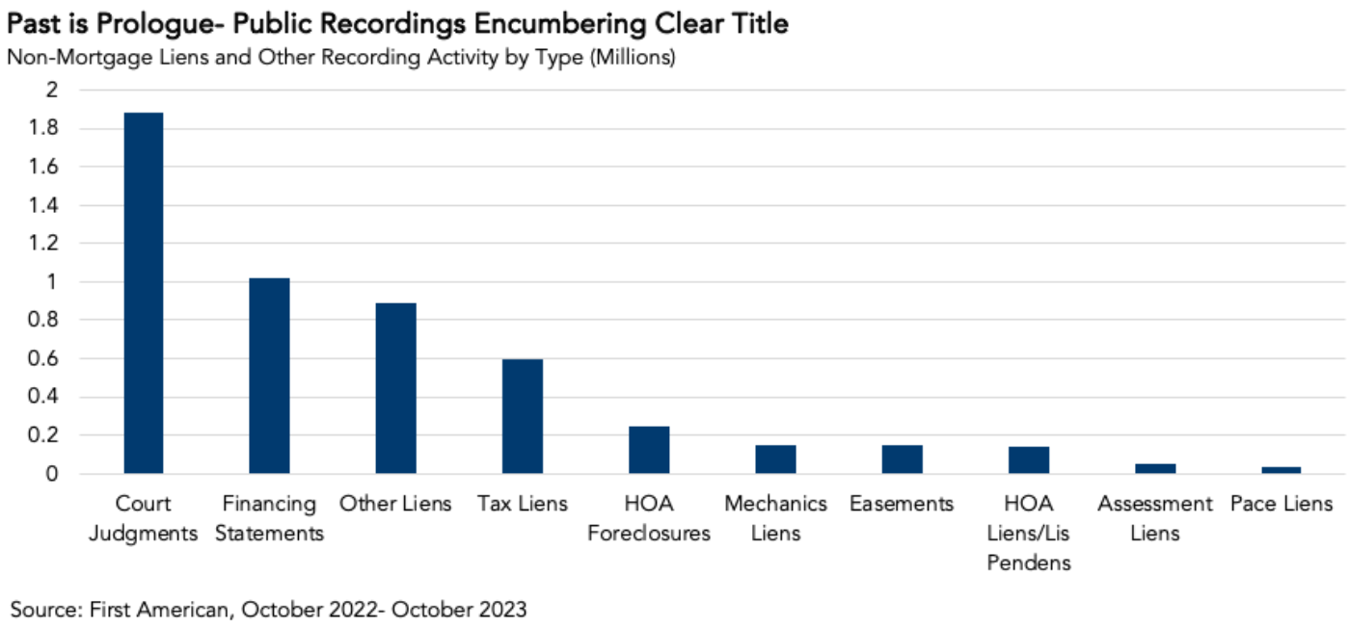
Industry research shows that in 2022 the title industry collected $2.4 billion overdue federal income taxes, $600 million overdue local property taxes, and $55 million overdue child support payments to clear the associated liens as part of their curative effort.
While most of the risk can be addressed prior to closing, title insurers pay significant sums each year in claims to address claims that don’t arise until after closing. In 2023, the industry paid out almost $640 million in claims, up from $596 million during 2022. Along with losses paid, title companies also pay legal defense costs for policyholders when their title is challenge. This defense cost is valuable since a significant portion of claims can be won in court ensuring the owner is not displaced from their home. The cost of paying and defending against a title claim can be extremely expensive. It often costs many thousands of dollars in litigation expenses, even if the claim is ultimately found not to have merit. The average American simply cannot afford to self-fund such defense costs, since the Federal Reserve has recently shown in its 2023 household survey that 37% of Americans could not cover even a hypothetical $400 emergency expense with a cash or a cash equivalent.
The costliest type of claim to address is fraud and forgery. Claims for fraud and forgery averaged a $143,000 payout over the last decade. Additionally, the amount of fraud and forgery claims have seen a large spike over the last several years, doubling as a percentage of claims in the category of basic risks in just the last two years. They ranged from 19% from 2013-2022 and then 21% in 2021 and 44% in 2022.
Response to Questions:
5. How are fees currently set? Who profits from the various fees? Who benefits from the service provided? What leverage or oversight do lenders have over third-party costs that are passed onto the consumer?
Like with any insurance product, title companies file their rates with state regulators. This process is overseen and governed by state insurance regulators in almost all states under the reverse preemption of McCarron Ferguson. While the CFPB does not have authority over the business of insurance and thus can not oversee the price of title insurance, the state regulators utilize their extensive authority to ensure prices are fair for consumers.
Under the various insurance laws, state insurance commissioners require insurers to provide actuarial data to justify their rates. In general state insurance law requires insurers show that rates are not excessive, inadequate, unreasonable or unfairly discriminatory. More than half the states cover just insurance while others include the title research and closing in the premium. States often sets rules and standards of practice that govern the provision of the service such as requirements that a title search of certain historical length is conducted prior to issuing the policy.
In most states, title insurers are required to file their rates prior to usage, with regulators either reviewing those rates before or shortly after they go into use. Three states (Florida, New Mexico and Texas) set mandatory state wide premiums. Five states do not have rate approval requirements.
No doubt the primary beneficiary of the services provided by title companies is the consumer (both home buyers and sellers). At the most basic level, the consumer benefits because without title insurance, they would not be able to obtain a mortgage loan and thus unable to purchase the home.
Beyond that the consumer benefits from the risk reduction provided by title companies. As discussed above, a home is often the single largest asset for Americans. Through the curative work discussed above, homeownership becomes more sustainable for the average American. Additionally, the insurance is vital to consumers and lenders since at least 30% of title defects cannot be found in a public records.
Beyond the curative the work title companies do at the closing table is also vital to protecting consumers. According to CertifID’s 2024 State of Wire Fraud report, nearly 1 in 4 consumers were targeted with suspicious or potentially fraudulent wire transfer instructions. 1 in 20 consumers were victimized into sending funds to the wrong person. FBI reports over $446m lost to real estate wire fraud last year. Further, the risk that the seller is not who they purport to be (called seller impersonation fraud) is also rising. Recent ALTA data shows 28% of title companies discovering at least one of these frauds last year.
Another unappreciated way the consumer benefits from title insurance is that it reduces the financial warranties they make to the lender, investors (like Fannie Mae, Freddie Mac and Ginnie Mae) and ultimately to the federal government. In every mortgage transaciton, the consumer executes a deed of trust or mortgage. Most often the standardized legal documents developed by Fannie and Freddie are utilized. In each of these documents the borrower makes the following warranty to the investor:
UNIFORM COVENANTS. Borrower and Lender covenant and agree as follows:
4. Charges; Liens. Borrower must pay (a) all taxes, assessments, charges, fines, and impositions attributable to the Property which have priority or may attain priority over this Security Instrument, (b) leasehold payments or ground rents on the Property, if any, and (c) Community Association Dues, Fees, and Assessments, if any. If any of these items are Escrow Items, Borrower will pay them in the manner provided in Section 3.
The Borrower must promptly discharge any lien that has priority or may attain priority over this Security Instrument unless Borrower: (aa) agrees in writing to the payment of the obligation secured by the lien in a manner acceptable to Lender, but only so long as Borrower is performing under such agreement; (bb) contests the lien in good faith by, or defends against enforcement of the lien in, legal proceedings which Lender determines, in its sole discretion, operate to prevent the enforcement of the lien while those proceedings are pending, but only until such proceedings are concluded; or (cc) secures from the holder of the lien an agreement satisfactory to Lender that subordinates the lien to this Security Instrument (collectively, the “Required Actions”). If Lender determines that any part of the Property is subject to a lien that has priority or may attain priority over this Security Instrument and Borrower has not taken any of the Required Actions in regard to such lien, Lender may give Borrower a notice identifying the lien. Within 10 days after the date on which that notice is given, Borrower must satisfy the lien or take one or more of the Required Actions.
- Form 3009 DC Deed of Trust
Additionally, lenders, investors and the public benefit from the title insurance product. Lenders and investors obtain insurance that makes their loans more salable on the secondary market. This credit enhancement is considered by rating agencies as they value a pool of mortgages. The public benefits from both the increase property values that flow from more certain property rights. They also benefit from the collection of debts as part of the curative process, especially the back taxes and child support identified above.
The value provided by the title industry also extends to the public good performed by maintaining accurate public records, effectively solving the “free-rider problem” inherent in the U.S. system of real property recordation.
8. Would lenders be more effective at negotiating closing costs than consumers? Are there reports or evidence that are relevant to the topic?
In the refinance marketplace, lenders that have been able to invest in more technology and integrations with title companies have been able to negotiate lower prices. This is due to insurers filing lower rates for these transactions because the technology reduces the cost to produce a policy by allowing better sharing of data. However, a general requirement for lenders to pay for title insurance is not likely to lead to similar results for most lenders. Unlike most service providers, insurance rate regulation requirements make it difficult for insurers to charge different prices for the same risk.
As discussed above, insurance regulators require title insurers to charge based on their filed rates. Thus, both consumers and lenders are not easily able to obtain a discount without getting a new rate filed and approved by the state.
The limitations on unfair discrimination in rates also limits the ability to alter prices for some or a small number of lenders who can guarantee a high amount of volume. Insurers have to charge the same rate based on the same risk and it would be difficult to justify a lower rate solely on a factor unrelated to risk (such as volume).
Both federal and state law limit the ability of title companies to offer discounts to lenders. Under the federal Real Estate Settlement Procedures Act, “No person shall give and no person shall accept any fee, kickback, or thing of value pursuant to any agreement or understanding, oral or otherwise, that business incident to or a part of a real estate settlement service involving a federally related mortgage loan shall be referred to any person.” Under RESPA’s implementing regulations the term “thing of value” is broadly interpreted to include a discount. Thus providing a discount pursuant to a negotiated agreement to refer business to a specific title company would likely violate RESPA. Thus, the ability of lenders to negotiate discounted prices will be hindered by risk of RESPA compliance.
Additionally it’s not clear that RESPA can be read to allow rate setting or mandate particular methods for payment of services. By excluding the lender pay provision found in competing bills in either the original RESPA or the 1975 amendments it suggests that the statute cannot be read to require such a scheme.
State law provides an additional layer of restriction to discounting title insurance pursuant to a referral agreement. Some states have mini versions of RESPA. However all states have variations of anti-inducement statutes for insurance. For example Florida’s anti-inducement statute states, “No title insurer, or any member, employee, attorney, agent, or agency thereof, shall pay, allow, or give, or offer to pay, allow, or give, directly or indirectly, as inducement to title insurance, or after such insurance has been effected, any rebate or abatement of the premium or any other charge or fee, or provide any special favor or advantage, or any monetary consideration or inducement whatever.” These state law restrictions mean that any attempt to amend RESPA or regulate using RESPA to allow lenders to negotiate volume discounts for title insurance will have a limited effect.
4. Provide data or evidence on the degree to which consumers shop for closing costs across settlement providers.
While TRID makes comparing costs relatively easy for consumers, there is little evidence that consumers shop for mortgages. When they do the evidence suggests they focus on the interest rate primarily.
ALTA has developed a consumer education campaign to help homebuyers understand the closing process and the benefits of title insurance. Through our consumer education portal (www.homeclosing101.org), we host a variety of resources to help consumers shop for title insurance, understand the steps in a closing, and review common terms and fees.
In addition we worked closely with the NAIC’s Title Insurance Task Force as it developed a consumer shopping tool. This effort brought regulators, industry and consumer groups together to develop an aid for consumers.
While its unclear how much of a benefit consumers would obtain through increased shopping, we are prepared to work with the CFPB to figure out how to promote more consumer shopping. Similar to the work we did together during the development and implementation of the Truth in Lending Act (TILA) and RESPA Integrated Disclosures (TRID). We would be happy to brainstorm ways to aid consumers in using TRID documents to aid in shopping.
Conclusion
Consumer protection is at the heart of what we do, whether its educating consumers about the latest fraud trends or helping answer questions as the complete their biggest purchase. We are ready to work with the bureau to aid consumers in better understanding their real estate transaction. Ultimately, for any discussion about how to help consumers to be fruitful, it needs to be based on facts about title insurance instead of the myths cited in this effort and the previous junk fee RFI. This letter provides the Bureau with those facts, and we expect you’ll consider them (along with the state-based regulation of insurance and limitations of your statutory authority) as you look for ways to help consumers.

ALTA analysis of NAIC annual financial statements filed with state insurance commissioners. Available at https://www.alta.org/business-operations/research-initiatives-and-resources/industry-financial-data/
ALTA represents title insurers, title agents and attorneys that provide peace of mind to Americans by insuring their property rights and closing their real estate transactions. Our members range from small, one-county operations to large national title insurers in the United States. The mission of ALTA is to improve the skills and knowledge of providers in the real property transaction, effectively advocate member concerns, and standardize products for industry use.
RFI (89 FR 48400, 48400 (June 6, 2024))
ndp | analytics. ALTA Critical Issues Study. More than pushing a button: Estimating the time and complexity of clearing title. April 2024, 240506-ALTA-Curative-Study-Executive-Summary.pdf
Id.
Financial Crimes Enforcement Network, Anti-Money Laundering Regulations for Residential Real Estate Transfers. 89 FR 12424, at 12456. Feb. 16, 2024.
Industry analysis of NAIC Form 9 Annual Statements.
See, National Association of Insurance Commissioner’s, 2023 Annual Property Casualty Insurance Industries Analysis. https://content.naic.org/sites/default/files/inline-files/2023%20Annual%20Property%20%26%20Casualty%20Insurance%20Industries%20Analysis%20Report.pdf
Mota, Nuno and Palim, Mark, Fannie Mae, “Barriers to Entry: Closing Costs for First-Time and Low-Income Homebuyers, December 2021, Barriers to Entry -- Closing Costs for First-Time and Low-Income Homebuyers (fanniemae.com)
Mota, Nuno and Palim, Mark, Fannie Mae, “Barriers to Entry: Closing Costs for First-Time and Low-Income Homebuyers, December 2021, Barriers to Entry -- Closing Costs for First-Time and Low-Income Homebuyers (fanniemae.com)
Fleming, Mark, First American Corporation, “Missing the Forest for the Fees – Borrower Life-of-Loan Costs” December 2023. https://www.firstam.com/value-of-title/costs-and-fees-of-homeownership/index.html
Based on data compiled and analyzed by First American. To identify the complete set of pre-curative risks First American used its own direct residential title commitments for sale transactions with or without loans or mortgage refinances between January 2014 and December 2023 that resulted in a policy (lender, owner, or both) written where policy liability amounts were between $1,000 and $15,000,000. These title commitments are the result of the search and examination process and have identified all the risks needing curation or insurance. For estimates of the losses, First American’s closed covered-risk claims related to search and examination from January 2008 to December 2023 were used to estimate, for each title risk type, the outlier-trimmed average net severity (including settlement, claim expenses and recovery costs). Finally, ALTA industry market share and industry direct premium written summary data from 2014 to 2023 was used to identify First American’s direct market share annually and to “gross up” industry estimates.
Both 2022 and 2023 risk exposure levels declined in large part due to the significant reduction in the number of sale transactions and mortgage refinances as mortgage rates increased from Pandemic-era lows.
Additionally, the relative cost can vary by the mixture of transaction types. When the mortgage market is heavily oriented toward refinance transactions rather than sales with mortgages, the average risk cost decreases because refinance transactions typically involve less title risk exposure compared to purchase (sales with mortgage) transactions. The mortgage market was refinance dominated for most of the last decade until the Federal Reserve started raising rates in early 2022.
First American Financial Corporation, 2024(First Am data)
Ernst & Young LLP, Economic Contribution of the U.S. Land Title Insurance and Settlement Services Industry in 2022, at I–II (Fig. 1) and 12, (Jan. 2024), available at: https://www.alta.org/file/2022-Economic-Contribution-Report.
Milliman, Analysis of Claims and Claims-Related Losses in the Land Title Insurance Industry, May 2024, https://www.alta.org/media/pdf/240517-analysis-of-claims-and-claims-related-losses-in-the-land-title-insurance-industry.pdf
Board of Governors of the Federal Reserve System, Economic Well-Being of U.S. Households in 2023, at 31–33 and Tables 16–17 (May 2024), available at: https://www.federalreserve.com/publications/files/2023-report-economic-well-being-us-households-202405.pdf (finding many Americans “would be unable to pay the expense at all” since 18% could only cover a $100 emergency expense and a further 14% only an expense of $100 to $499).
Milliman, Analysis of Claims and Claims-Related Losses in the Land Title Insurance Industry, May 2024, https://www.alta.org/media/pdf/240517-analysis-of-claims-and-claims-related-losses-in-the-land-title-insurance-industry.pdf
See 15 U.S.C. 1011 (“Congress hereby declares that the continued regulation and taxation by the several States of the business of insurance is in the public interest, and that silence on the part of the Congress shall not be construed to impose any barrier to [that] regulation…by the several States.”); 15 U.S.C. 1012 (“The business of insurance, and every person engaged therein, shall be subject to the laws of the several States which relate to the regulation or taxation of such business....No Act of Congress shall be construed to invalidate, impair, or supersede any law enacted by any State for the purpose of regulating the business of insurance…unless such Act specifically relates to the business of insurance.”).
12 USC 5517(f). “The Bureau shall have no authority to exercise any power to enforce this title 1 with respect to a person regulated by a State insurance regulator.”
National Association of Insurance Commissioners (NAIC), NAIC Model Laws, Regulations, Guidelines, and Other Resources, “Title Insurance Agent Model Act,” Section 19. July 2003. MDL-230 (naic.org).
NAIC, Survey of State Insurance Laws Regarding Title Data and Title Matters. March 2019. https://content.naic.org/sites/default/files/inline-files/cmte_c_title_tf_survey_state_insurance_laws_march_2018.pdf
Milliman, Analysis of Claims and Claims-Related Losses in the Land Title Insurance Industry, May 2024, https://www.alta.org/media/pdf/240517-analysis-of-claims-and-claims-related-losses-in-the-land-title-insurance-industry.pdf
https://www.certifid.com/state-of-wire-fraud
See uniform security instruments provided at https://singlefamily.fanniemae.com/fannie-mae-legal-documents.
https://www.spglobal.com/ratings/en/sector/structured-finance/rmbs
Charles Szypszak, Public Registries and Private Solutions: An Evolving American Real Estate Conveyance Regime, 24 Whittier L. Rev. 663 (2003).; idem, Legal Protection of Property Rights in the Self-Regulating United States Local Recording System, 9 Adam Mickiewicz Univ. L. Rev. 9, 11–13 (2019), available at: https://ppuam.amu.edu.pl/uploads/PPUAM%20vol.%209/01_Szypszak.pdf (“In essence, those acquiring property interests must protect themselves—it is a ‘user beware’ system. . . . Registers of deeds in the United States do not check to see whether someone recording a document has a legitimate interest in the rights it describes, or whether the conveyance complies with any applicable regulations. One reason why the American real estate conveyance system is so efficient is that the parties are free to structure and consummate their arrangements without the deed for government review or approval.”).
12 USC 2607(a)
12 USC § 2602(2); 12 CFR § 1024.14(d)
See S. 3232, 93d Cong., 2d Sess. (1974). At the time that Congress enacted RESPA in 1974 (and the further amendments in 1975), Senator William Proxmire introduced a bill that would have required all settlement services to be “paid” by lenders, prohibited origination fees and discount points, and required all lender compensation to be obtained through the interest rate charged on the loan.
See Title 55, Chapter 27.3 of the Code of Virginia, Sections 55-525.16 – 55-525.32.
National Association of Insurance Commissioners (NAIC), NAIC Model Laws, Regulations, Guidelines, and Other Resources, “Unfair Trade Practices Act,” Spring 2021. https://content.naic.org/sites/default/files/inline-files/MDL-880_0.pdf
FL 626.5941
https://www.consumerfinance.gov/about-us/newsroom/cfpb-report-finds-nearly-half-of-borrowers-do-not-shop-for-a-mortgage/
https://www.fanniemae.com/research-and-insights/perspectives/homebuyers-shop-around-mortgages
https://content.naic.org/sites/default/files/committee_related_documents/committees_c_title_tf_related_shopping_too_template.pdf

